**Information Ethics**

Venkata Ashok Kumar Reddy Maram

Graduate & Prof Skill Development

New England College

July 28, 2022

**You MUST watch each of these videos. Take notes on each one. Highlighting the most important points. Submit a copy of your notes indicating when you watched each module. If you took notes by hand, please submit images collected in a Word document.**

**Information Ethics Links**

**Tutorial: Academic Integrity**

**LTI:**<https://frame.credocourseware.com/lti_provider/courses/course-v1:New-England-College-NH+Core+Core/block-v1:New-England-College-NH+Core+Core+type@sequential+block@693b8f5cc8c94f65a236fc33de96eae7>

Direct Link: <https://www.nec.gmilcs.org/login?url=https://frame.credocourseware.com/courses/course-v1:New-England-College-NH+Core+Core/xblock/block-v1:New-England-College-NH+Core+Core+type@sequential+block@693b8f5cc8c94f65a236fc33de96eae7/>

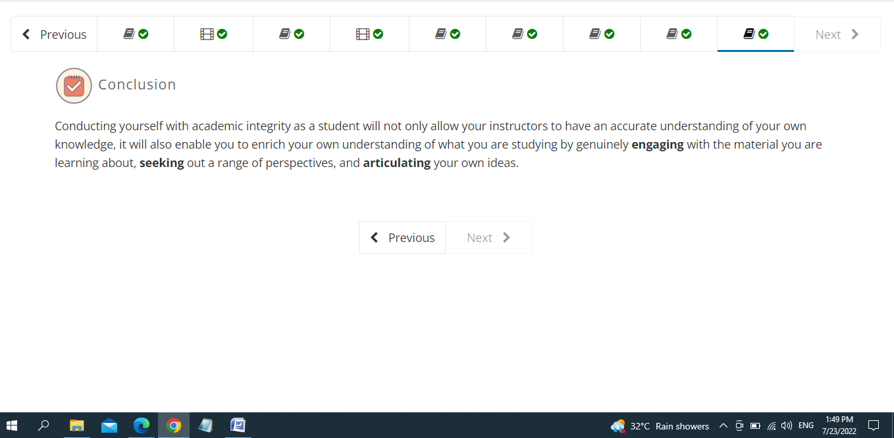

**Tutorial: Information Has Value**

**LTI:** <https://frame.credocourseware.com/lti_provider/courses/course-v1:New-England-College-NH+Core+Core/block-v1:New-England-College-NH+Core+Core+type@sequential+block@4e58b49acbce45bfad1a72e7f0901c2b>

Direct Link: <https://www.nec.gmilcs.org/login?url=https://frame.credocourseware.com/courses/course-v1:New-England-College-NH+Core+Core/xblock/block-v1:New-England-College-NH+Core+Core+type@sequential+block@4e58b49acbce45bfad1a72e7f0901c2b/>

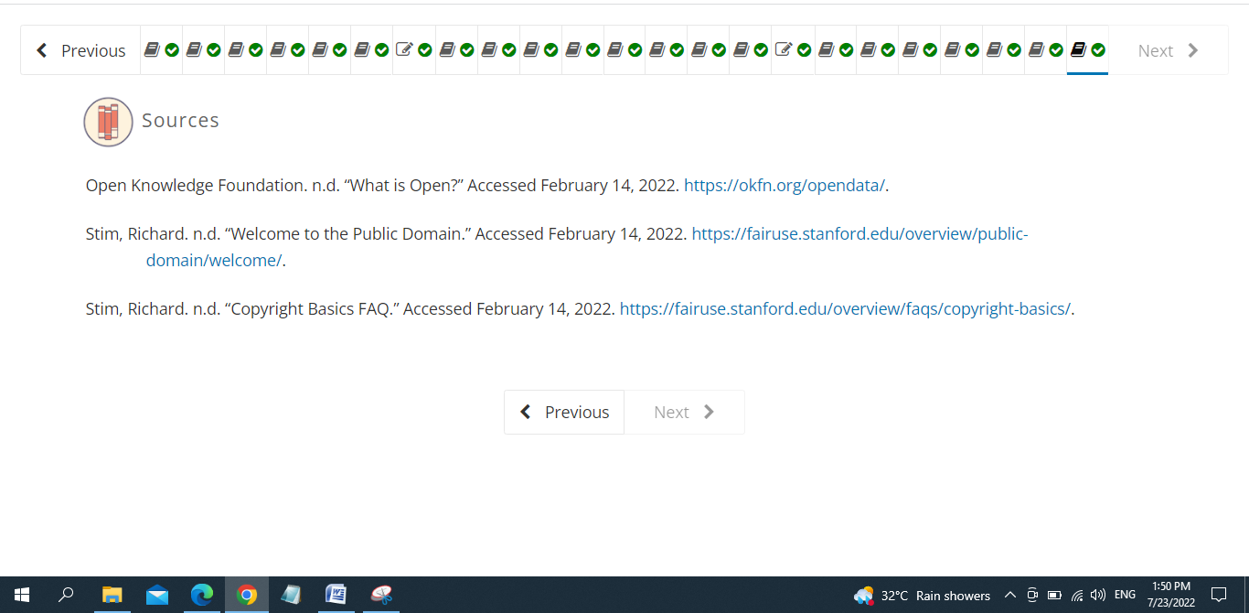

**Video: Plagiarism**

**LTI:**<https://frame.credocourseware.com/lti_provider/courses/course-v1:New-England-College-NH+Core+Core/block-v1:New-England-College-NH+Core+Core+type@sequential+block@fad5c03cc00a44a89792b7733dd4774c>

Direct Link: <https://www.nec.gmilcs.org/login?url=https://frame.credocourseware.com/courses/course-v1:New-England-College-NH+Core+Core/xblock/block-v1:New-England-College-NH+Core+Core+type@sequential+block@fad5c03cc00a44a89792b7733dd4774c/>

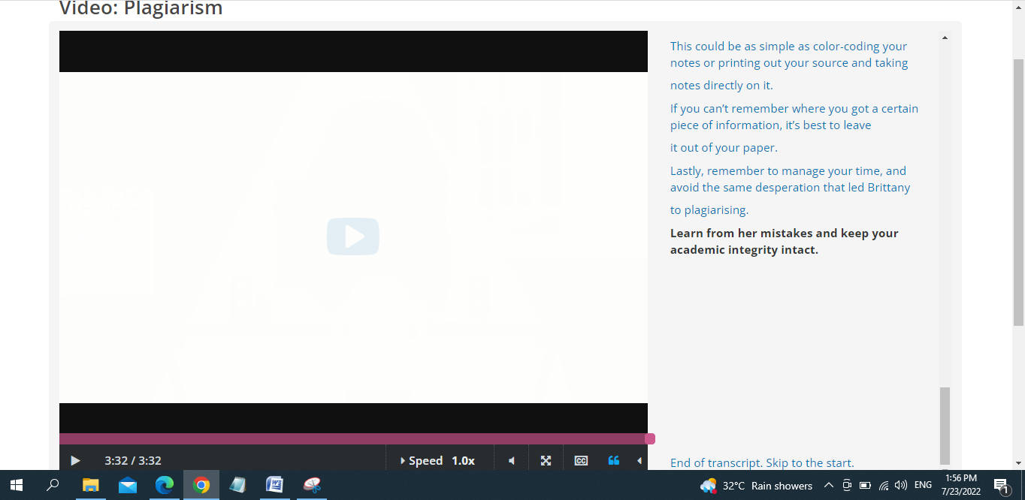

**Tutorial: Copyright**

**LTI:**<https://frame.credocourseware.com/lti_provider/courses/course-v1:New-England-College-NH+Core+Core/block-v1:New-England-College-NH+Core+Core+type@sequential+block@14d79a159b804f368d7f3026d61e7652>

Direct Link: <https://www.nec.gmilcs.org/login?url=https://frame.credocourseware.com/courses/course-v1:New-England-College-NH+Core+Core/xblock/block-v1:New-England-College-NH+Core+Core+type@sequential+block@14d79a159b804f368d7f3026d61e7652/>

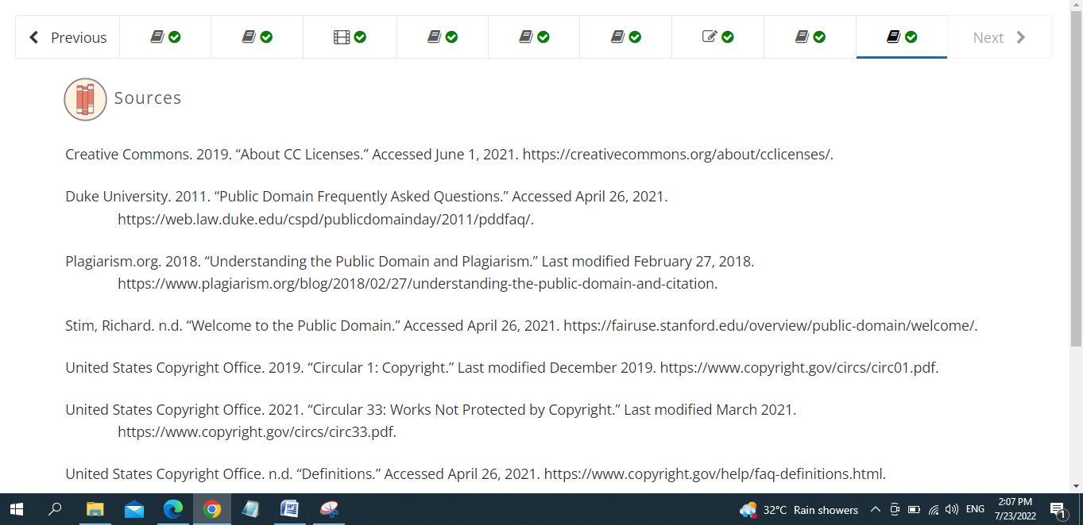

**Quiz: Information Ethics**

**LTI:**<https://frame.credocourseware.com/lti_provider/courses/course-v1:New-England-College-NH+Core+Core/block-v1:New-England-College-NH+Core+Core+type@sequential+block@b68a3d681a0649d28f6b8966a3edc909>

Direct Link: <https://www.nec.gmilcs.org/login?url=https://frame.credocourseware.com/courses/course-v1:New-England-College-NH+Core+Core/xblock/block-v1:New-England-College-NH+Core+Core+type@sequential+block@b68a3d681a0649d28f6b8966a3edc909/>

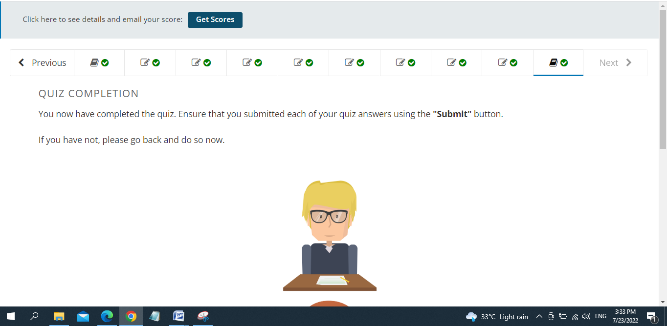

Since they are also part of the Information Ethics section, I’ll go ahead and also include the Digital Citizenship stuff after the Information Ethics quiz.

**Tutorial: Digital Privacy**

**LTI:**<https://frame.credocourseware.com/lti_provider/courses/course-v1:New-England-College-NH+Core+Core/block-v1:New-England-College-NH+Core+Core+type@sequential+block@284f5a8fd5bc4632b5a2da1fd98bb35a>

Direct Link: <https://www.nec.gmilcs.org/login?url=https://frame.credocourseware.com/courses/course-v1:New-England-College-NH+Core+Core/xblock/block-v1:New-England-College-NH+Core+Core+type@sequential+block@284f5a8fd5bc4632b5a2da1fd98bb35a/>

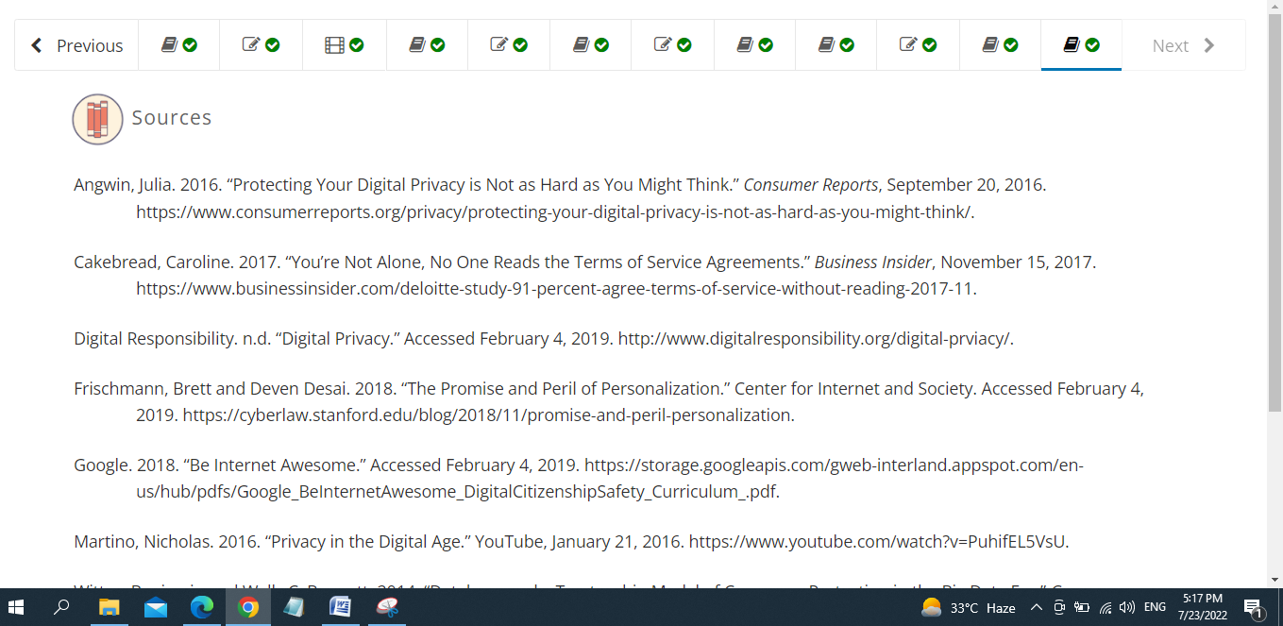

**Video Tutorial: Introduction to Digital Citizenship**

**LTI:**<https://frame.credocourseware.com/lti_provider/courses/course-v1:New-England-College-NH+Core+Core/block-v1:New-England-College-NH+Core+Core+type@sequential+block@9c0a8dbb8f584f239b0745fa533da5b1>

Direct Link: <https://www.nec.gmilcs.org/login?url=https://frame.credocourseware.com/courses/course-v1:New-England-College-NH+Core+Core/xblock/block-v1:New-England-College-NH+Core+Core+type@sequential+block@9c0a8dbb8f584f239b0745fa533da5b1/>

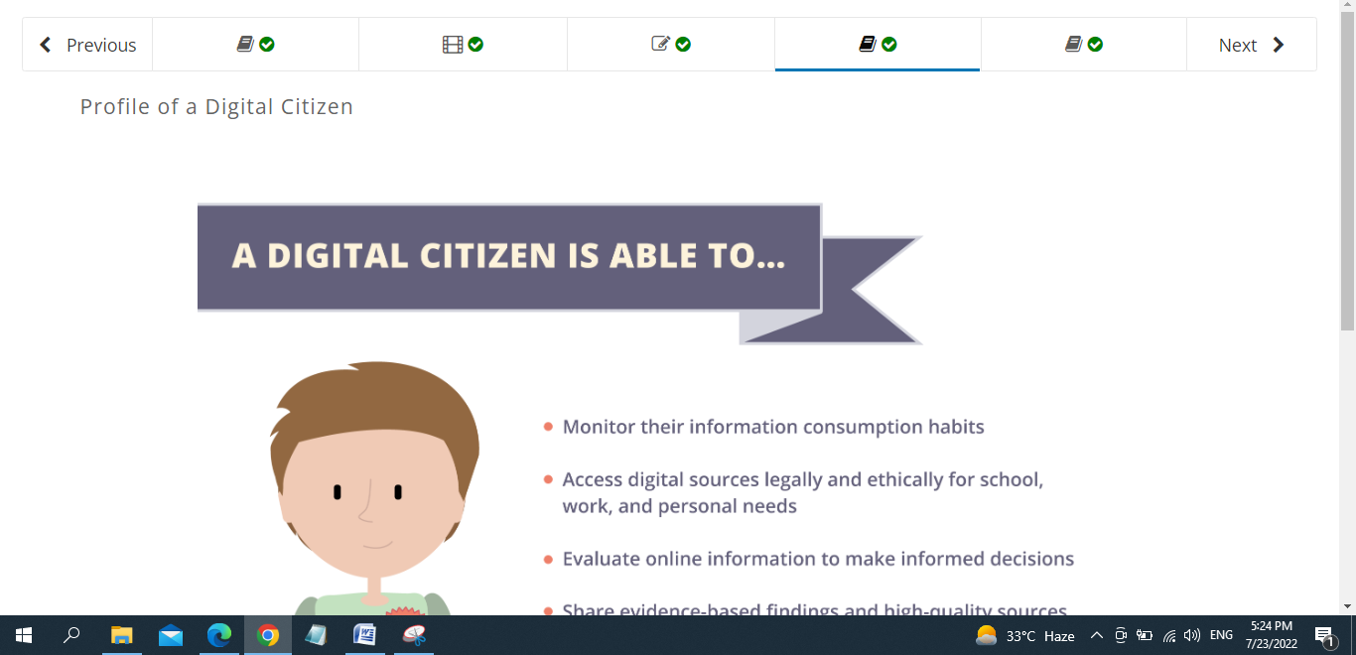

**Tutorial: Digital Citizenship in Practice**

**LTI:**<https://frame.credocourseware.com/lti_provider/courses/course-v1:New-England-College-NH+Core+Core/block-v1:New-England-College-NH+Core+Core+type@sequential+block@5a8645218c564d549778092622c46b3e>

Direct Link: <https://www.nec.gmilcs.org/login?url=https://frame.credocourseware.com/courses/course-v1:New-England-College-NH+Core+Core/xblock/block-v1:New-England-College-NH+Core+Core+type@sequential+block@5a8645218c564d549778092622c46b3e/>

